Interview Questions

Next Greatest Element:
import java.util.*;
class next{
public static void main(String[] args){
Scanner sc=new Scanner(System.in);
System.out.println("Enter the N: ");
int n=sc.nextInt();
int[] arr=new int[n];
System.out.println("Enter the array : ");
for(int i=0;i<n;i++){
arr[i]=sc.nextInt();
}
int[] res=new int[n];
for(int i=0;i<n;i++){
res[i]=-1;
for(int j=i;j<n;j++){
if(arr[i]<arr[j]){
res[i]=arr[j];
break;
}
}
}
for(int a:res){
System.out.print(a+" ");
}

}
}

Output:
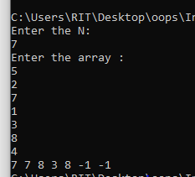

Furthest greatest Element:
import java.util.*;
class fur{
public static void main(String[] args){
Scanner sc=new Scanner(System.in);
System.out.println("Enter the N: ");
int n=sc.nextInt();
int[] arr=new int[n];
System.out.println("Enter the array : ");
for(int i=0;i<n;i++){
arr[i]=sc.nextInt();
}
int[] res=new int[n];
for(int i=0;i<n;i++){
res[i]=-1;
for(int j=n-1;j>i;j--){
if(arr[i]<arr[j]){
res[i]=arr[j];
break;
}
}
}
for(int a:res){
System.out.print(a+" ");
}

}
}
Output:
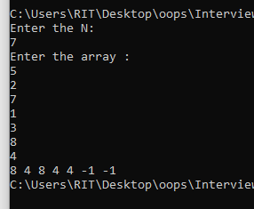

Get Digit in a String and get the sum:
import java.util.*;
class cdigit{
public static void main(String[] args){
Scanner sc=new Scanner(System.in);
System.out.println("Enter the String: ");
String str=sc.nextLine();
int count=0;
int num=0;
for(int i=0;i<str.length();i++){
char ch=str.charAt(i);
if(Character.isDigit(ch)){
num=num*10+(ch-'0');
}
else{
count+=num;
num=0;
}
}
count+=num;
System.out.println(count);
}
}
Output:
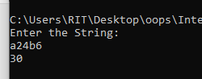

Print even index Element in descending order and Odd index element in ascending Order:
import java.util.*;
class order {
public static void main(String[] args) {
Scanner sc = new Scanner(System.in);
System.out.print("Enter the N: ");
int n = sc.nextInt();
int[] arr = new int[n];
System.out.print("Enter the array: ");
for (int i = 0; i < n; i++) {
arr[i] = sc.nextInt();
}
int[] odd = new int[n];
int[] even = new int[n];
int oddCount = 0, evenCount = 0;
for (int i = 0; i < n; i++) {
if (arr[i] % 2 == 0)
even[evenCount++] = arr[i];
else
odd[oddCount++] = arr[i];
}
for (int i = 0; i < oddCount - 1; i++) {
for (int j = i + 1; j < oddCount; j++) {
if (odd[i] > odd[j]) {
int temp = odd[i];
odd[i] = odd[j];
odd[j] = temp;
}
}
}
for (int i = 0; i < evenCount - 1; i++) {
for (int j = i + 1; j < evenCount; j++) {
if (even[i] < even[j]) {
int temp = even[i];
even[i] = even[j];
even[j] = temp;
}
}
}
int i = 0, j = 0, k = 0;
while (i < oddCount && j < evenCount) {
arr[k++] = odd[i++];
arr[k++] = even[j++];
}
while (i < oddCount) {
arr[k++] = odd[i++];
}
while (j < evenCount) {
arr[k++] = even[j++];
}
System.out.print("Output: ");
for (int x : arr) {
System.out.print(x + " ");
}
}
}
Output:
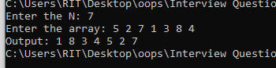

String problem:

import java.util.*;
class uncom{
public static void main(String[] args){
Scanner sc=new Scanner(System.in);
System.out.println("Enter the String: ");
String s1=sc.nextLine();
String s2=sc.nextLine();
Set<Character> s=new LinkedHashSet<>();
for(int i=0;i<s1.length();i++){
char ch=s1.charAt(i);
s.add(ch);
}
for(int i=0;i<s2.length();i++){
char a=s2.charAt(i);
if(s.contains(a)){
s.remove(a);
}
}
for(char x:s){
System.out.print(x);
}
}
}
Output:
